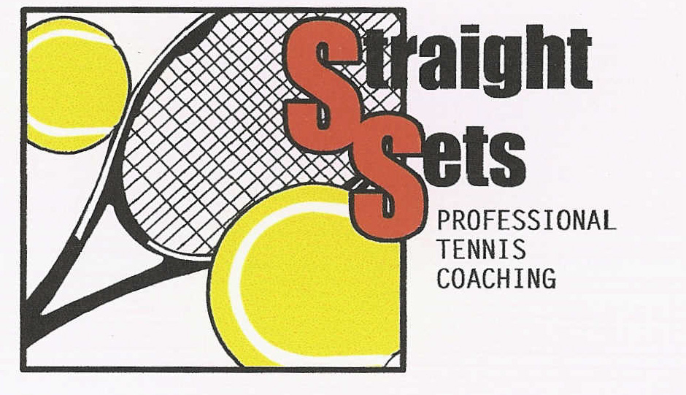

KELLY COOPER
HIGH PERFORMANCE TENNIS COACH

Mobile: 0414 874 482

ABN: 17 188 590 01

Email: str8.sets@bigpond.com

Welcome to Straight Sets’ Professional Tennis Coaching. We, the coaching team, value your decision to commit to our program.
On the adjacent side there is a complete outline of the Coaching Team.
We will be endeavoring to provide a fun, learning environment where the children are involved in all aspects of the lesson.
Children progress at vastly different rates and have varying potentials. It is our job to get the most out of your child’s ability.
We encourage you to keep the communication lines open, to ensure we continue to provide you with a professional tennis coaching service. Both positive and negative feedback would be appreciated.
Please do not hesitate to contact Kelly to discuss any matter that may concern you.

THE COACHING PROGRAM - The following is a range of services we offer:

HOT SHOTS GROUP COACHING – ORANGE & GREEN BALL

- 4 - 7 years old: 45-minute lesson - $275.00 per 10-week term - maximum 4-5 per coach.
- EMPHASIS on LEARNING BASIC SKILLS, FUN and MOVEMENT.
- STROKES and AREAS COVERED are
- FOREHAND / BACKHAND / VOLLEY / SMASH/ SERVE
- Doubles maybe introduced depending on the standard of the group.

- 7 - 18 years old: 45-minute lesson - $275.00 per 10-week term - maximum 4-5 per coach.
- EMPHASIS on CORRECT TECHNIQUE, FUN and MOVEMENT.
- ALL STROKES are COVERED DURING the TERM:
FOREHAND/BACKHAND/VOLLEY/SMASH/LOB/SERVE/DOUBLES PLAY.
- Combinations of all strokes and running drills will also be incorporated.

This is a preparation phase for children:
1. WANTING to LEARN the GAME of TENNIS
2. INTERESTED IN PLAYING COMPETITION
3. ALREADY PLAYING COMPETITIVELY

SQUAD COACHING – BEGINNER TO ADVANCED – YELLOW & GREEN BALL

10 - 18 years old: 90-minute lesson - $385.00 per 10-week term (maximum of 6-8 per coach)

- This program is designed for children who have chosen tennis as their sport and want to get the most out of their ability. A practice session each week is strongly recommended as well as competition to develop maximum improvement. Children are generally invited into these Squads by the coaches, but enquiries are welcomed.

- The 90-minute session is divided up into 3 parts, each being 30 minutes long.
1. TECHNIQUE WORK
2. DRILLS / TACTICS / STRATEGIES / SHOT SELECTION/ FITNESS
3. MATCH PLAY (e.g. Children play a either singles or doubles competitively each week)

We encourage all children who are participating in Squad Coaching to consider 1 private lesson every 2nd week during the term. This will ensure that their technique is maintained / improved. The intense work on specific weaknesses can rapidly improve the athlete’s game.

LADIES / ADULT GROUP COACHING: - Designed for all standards from beginner to advanced players.

60 minutes $330 per 10-week term (4-5 adults)

The 60 / 90-minute session is divided up into 3 parts.
1. TECHNIQUE WORK
2. DRILLS / TACTICS / STRATEGIES / SHOT SELECTION/ FITNESS
3. MATCH PLAY (e.g. doubles)

CARDIO TENNIS: – Designed for all standards beginners - advanced players.

CARDIO IS A TENNIS BASED LESSON OF FUN AND FITNESS FOR 1 CONTINUOUS HOUR!
GET READY FOR A GREAT WORK OUT!
ALL ARE WELCOME TO COME ALONG AND JOIN THE FUN & BRING A FRIEND!
(Racquets can be provided)

PRIVATE COACHING: – For all students / adults that want to improve quickly!!
A great opportunity to work on a weakness, develop strengths or simply learn the game.

$55.00 PER 30 MINUTE LESSON
$82.50 PER 45 MINUTE LESSON
$110.00 PER 60 MINUTE LESSON

$72.00 PER 30 MINUTE SEMI PRIVATE LESSON (2 persons)
$96.00 PER 45 MINUTE SEMI PRIVATE LESSON (2 persons)
$120.00 PER 60 MINUTE SEMI PRIVATE LESSON (2 persons)

Please note: During the winter months – Term 2 & 3 a light fee will also be included as an additional fee.
30 mins - $5 per week / 45 mins - $7.50 per week & 60 mins – $10 per week – these prices are divided for Semi Privates.

CANCELLATION POLICY:

Group and Squad Coaching – if you are unable to attend for any reason you will be entitled to
1 rescheduled make up lesson per term, this class will be made up on another day/time during that Term. (If a medical certificate is provided then make up lessons will continue to apply)

Private / Semi Private cancellation fees will apply if you are unable to attend your private lesson for any reason (excluding weather). Communication 24 hours prior to your scheduled private lesson is required to ensure we can reschedule and you do not incur the late cancellation fee of the lesson
(unless a medical certificate is provided)

If you decide to pull out of any of the above after committing to the 10-week coaching term for any reason unless a medical certificate is provided, then 50% of the total payment will be invoiced.

OTHER SERVICES:

- JUNIOR COMPETITION (Saturday and Sunday Morning)
- RACQUET RESTRINGS / GRIPS & REPAIRS from $40.00 PER RACQUET – 24 HOUR SERVICE
- TENNIS ONLY HAWTHORN – Provide an extensive range of tennis equipment, clothing and shoes

WET WEATHER PROCEDURE:

The Coaching Staff will let you know ASAP if coaching is cancelled due to weather via a text message!

Kelly: (m) 0414 874 482 - All Booking and Enquiries
Aniket: (m) 0401 184 505
Chad: (m) 0421 006 927

IF NO ONE ANSWERS? - We are on court coaching

ALL Coaching will only be cancelled if it is pouring with rain at the time of your lesson.
The coaching program is a GUARANTEED 10 week ON COURT term, if your lesson is cancelled due to poor weather, we simply continue the following week until we get the 10 lessons in or
we will endeavor to reschedule to a convenient time.

We hope that you and your children enjoy our coaching program. It is designed to ensure that all participants obtain the maximum benefit from their involvement. If you have any queries / feedback please don’t hesitate to contact me.

Keep Swinging
Kelly & The Coaching Team

THE COACHING TEAM

1. KELLY COOPER: DIRECTOR / HEAD COACH - TCA – HIGH PERFORMANCE COACH

Kelly has had 30 years coaching experience. She has been in the business independently for 25 years running various clubs
in Melbourne. She is fervent to ensure that every student is nurtured, so that his or her tennis is both enjoyable and rewarding,
whilst ensuring they meet their desired goals and achieve the most of their ability.
Kelly was previously a world ranked professional WTA player in both Singles and Doubles.
Kelly has played 20 years of State Grade Pennant for various clubs in Melbourne - the highest level of Victorian Competition.
She has played in the Australian National Team over 35 years and Victorian Pennant for Hawthorn Tennis Club.
Kelly has coached/managed U10 / U12 & U14 Australian teams over the past 6 - 8years, nationally and internationally.
Kelly handles all administration and booking details.

2. ANIKET (ANI) GHASKADVI: HEAD COACH - CLUB PROFESSIONAL ADVANCED COACH

Aniket has coached a variety of standards ranging from beginner to high performance, both junior and senior players for
over 15 years. Aniket has also a degree in Exercise and Sports Science with major in Sports Nutrition and Sports
Coaching through Deakin University. He travelled with the Junior Davis Cup and State Teams in India, along with officiating
for the Commonwealth Games. He has played Grade 1 Pennant for Hawthorn Tennis Club for many years, with a Career ranking of 700 in the world. In junior years he was ranked top 10 in India. He has a great rapport with both juniors and senior players. Aniket is an enthusiastic and highly motivated to achieve the best from all clients. His leadership and hard work are capitalized by his warmth and genuine people skills that assists both on and off the court.

3. CHAETAIN (CHAD) BHULLER: HEAD COACH - JUNIOR DEVELOPMENT COACH

Chad has been a part of the Straight Sets team working with Kelly for the past 5 years with Hot Shots / Squad Coaching / Cardio / Adults and Private lessons (Junior and Senior). He has had 8 years coaching experience.
During year 11&12 he attended a Sports Development School which focused on not only playing / coaching tennis but also a
variety of sports coaching.
Chad has played a high level of tennis in his junior years as well as Victorian Pennant.
Chad has continued to advance his knowledge of the technical and tactical components of tennis ensuring he takes his clients to the next level. Chad is a hardworking and disciplined coach – this transpires onto his clients as he enthusiastically motivates them in all aspects on court.

4. ANTHONY LUPPINO: HEAD COACH - JUNIOR DEVELOPMENT COACH

Anthony has coached and played at the club since he was a junior (approx.10 years old) making him well versed in the coaching industry and structure at Straight Sets. Anthony has experienced coaching all ages and different standards of tennis from beginner – high performance players. Anthony has always had a great passion for tennis, actively competing in Pennant, Saturday Afternoon Comp & Night Tennis now in his senior years.
Anthony has displayed a fantastic rapport with all clientele and is incredibly passionate, enthusiastic and a warm natured person who is highly motivated, striving to further develop his coaching abilities and provide the best possible experience for all his students.

5. VIRGINIA WALLACE: HEAD COACH - JUNIOR DEVEOPMENT COACH

Virginia is our newest member to the coaching team. Virginia is a lifelong tennis player, growing up playing Club Tennis as a Junior and now continues as an adult playing Victorian Pennant.
Originally a lawyer, however her true passion is tennis coaching. Whilst living interstate and in Regional Victoria she has been involved in various local clubs and tennis communities.
Virginia has assisted in various coaching operations. With tennis being her true passion, she is keen to give back to the game she loves, encouraging all players to take up the game which they can play at all stages of life.
Virginia is currently working towards her Level 1 Junior Development Qualifications with Tennis Australia.
Virginia is vibrant and enthusiastic, you can see this shining through as she strives to ensure all clients /players get the most out of their ability and tennis experience.

6. XAVIER (CHAVI) AULADELL: TA ADVANCED PRO COACH EQUIVALENT

Xavier is an international coach from Spain. He has been residing and coaching in Sydney Australia for the past year and he has recently moved to Melbourne to finish his master’s degree in chemical engineering for the next 2 years.
We are very fortunate to be able to have him coaching at Straight Sets within our team. He has a lot of experience in coaching internationally as well as here in Australia. He has previously worked at the Rafa Nadal Academy.
He is a very committed and passionate tennis coach, always striving to improve the client’s game and work holistically in his approach to improvement.

There is an outlined week-by-week coaching program in which all coaches follow throughout the term.

SAFEGUARDING CHILDREN’S POLICY
Straight Sets is committed to the safeguarding of children.
We continue to adopt the Tennis Australia Safeguarding Children’s Code of Conduct and Membership Protection Policy. We are dedicated to ensuring the safety of children
http://www.tennis.com.au/childsafe

